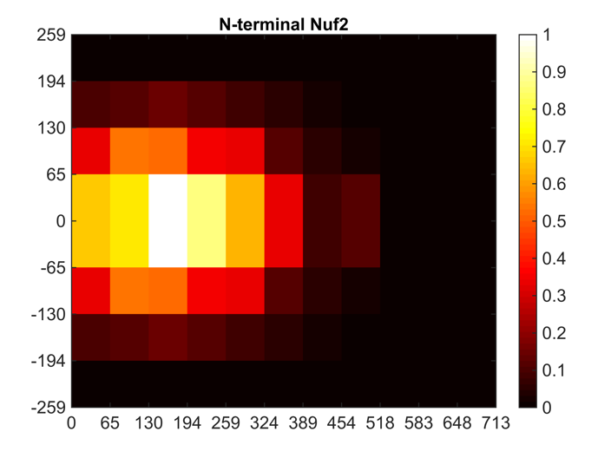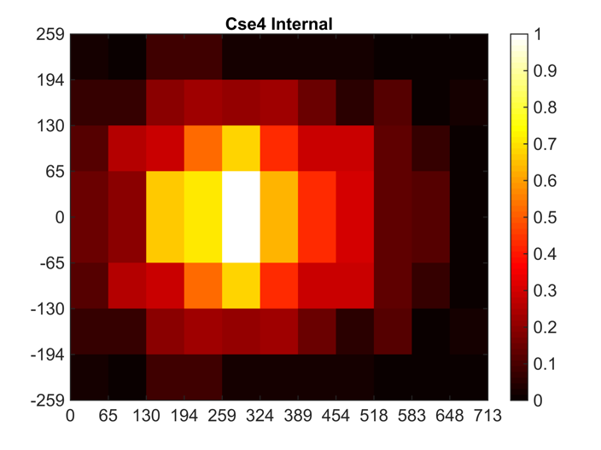

|  |  |  |
| --- | --- | --- |
|  | N-terminal Nuf2 | Cse4 Internal |
| Mean Relative X-position (nm) | 189 ± 108 | 300 ± 136 |
| Mean Relative Y-position (nm) | 63 ± 45 | 79 ± 57 |
| Mean Kinetochore Height (nm) | 368 ± 34 | 420 ± 61 |
| Mean Spindle Pole Body Height (nm) | 290 ± 46 | 296 ± 61 |
| Number Cells Analyzed | 528 | 361 |

Table 1. Two-dimensional spindle lengths between 800 and 1800 nm.